## Step 1: Create the Module

1. Create a new file named mortgage.js in the js directory.
2. Copy the calculateMonthlyPayment and calculateAmortization functions from main.js into mortgage.js.
3. Add the export keyword in front of both functions to make them available as part of the module public API. mortgage.js should now look like this:

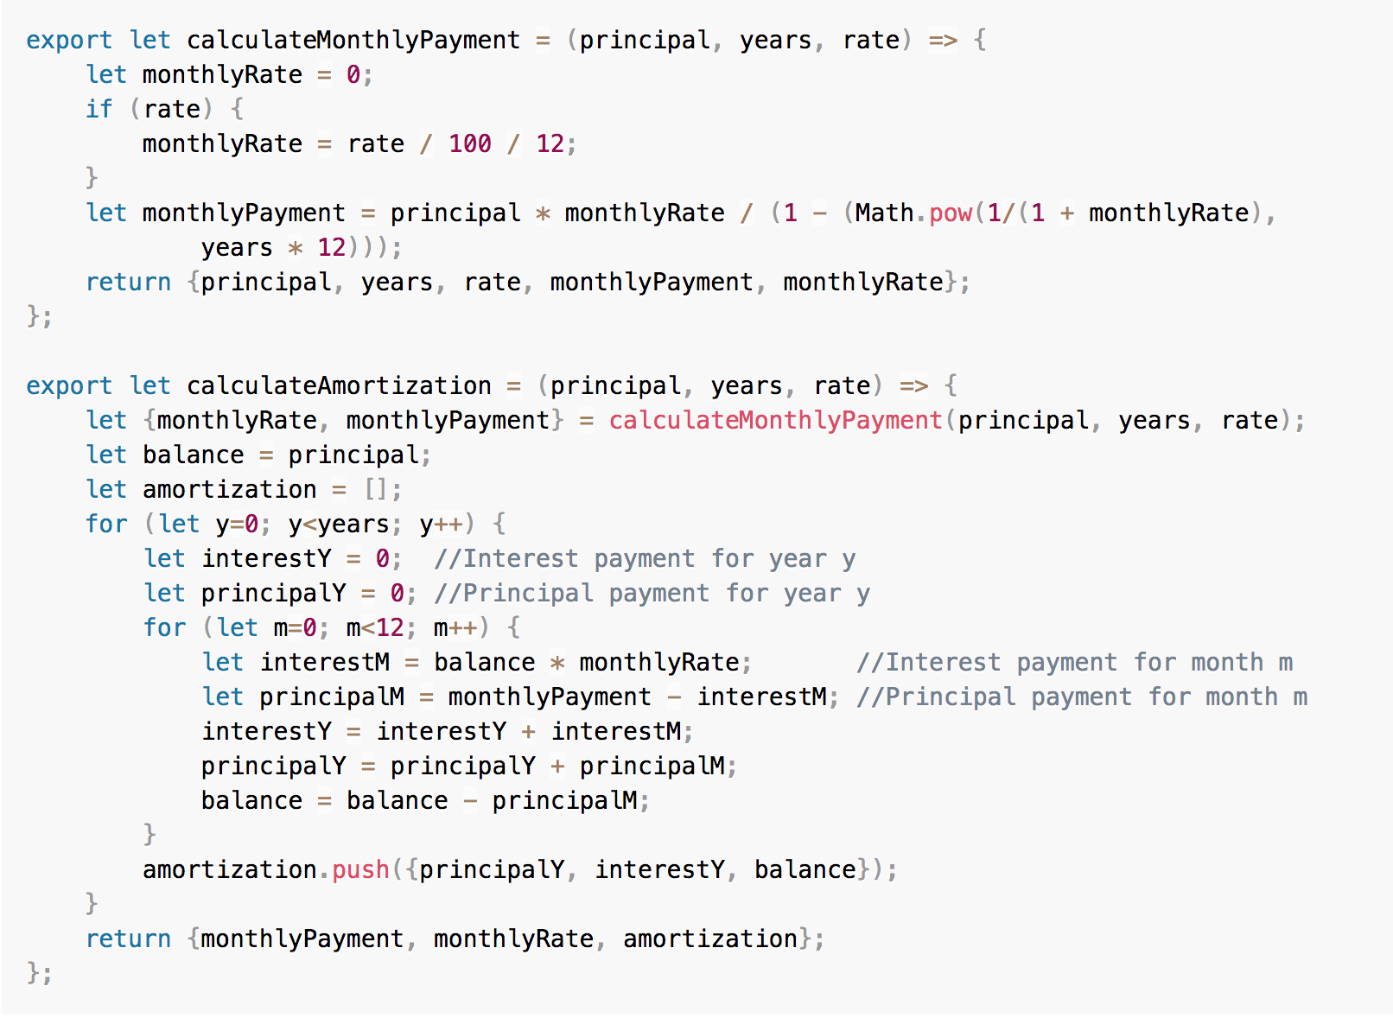

## Step 2: Use the Module

1. In main.js, remove the calculateMonthlyPayment and calculateAmortization functions.
2. Add the following import statement as the first line in main.js to import the mortgage module:

import * as mortgage from './mortgage';

1. In the **calcBtn** click event handler, modify the call to the calculateAmortization function as follows:

let {monthlyPayment, monthlyRate, amortization} =

mortgage.calculateAmortization(principal, years, rate);

## Step 3: Build and Run

1. On the command line, type the following command to rebuild the application:

npm run webpack

1. Open a browser, access http://localhost:8080, and click the **Calculate** button.